MEMBUAT SHOPPING LIST

1. MENGGUNAKAN useState().

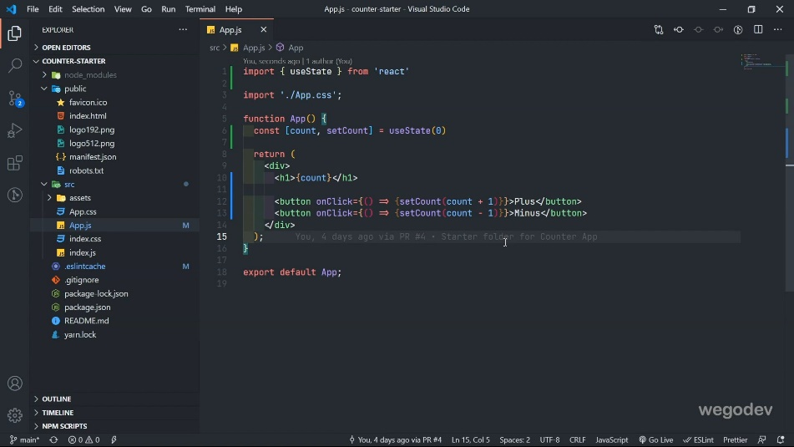

1. Crate Navigation element

* Buat fragmen kosong
  + 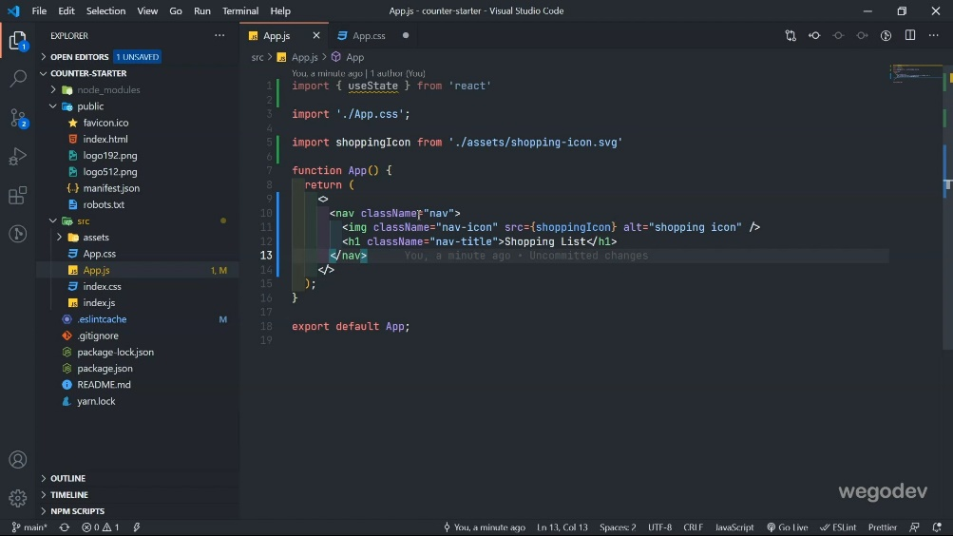

1. Create Container section

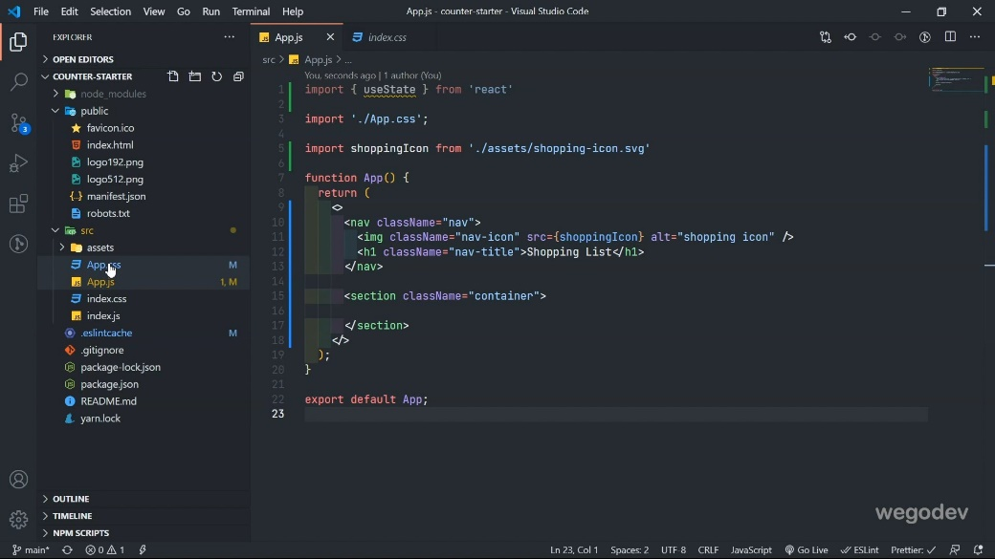

1. Create search input inside of container

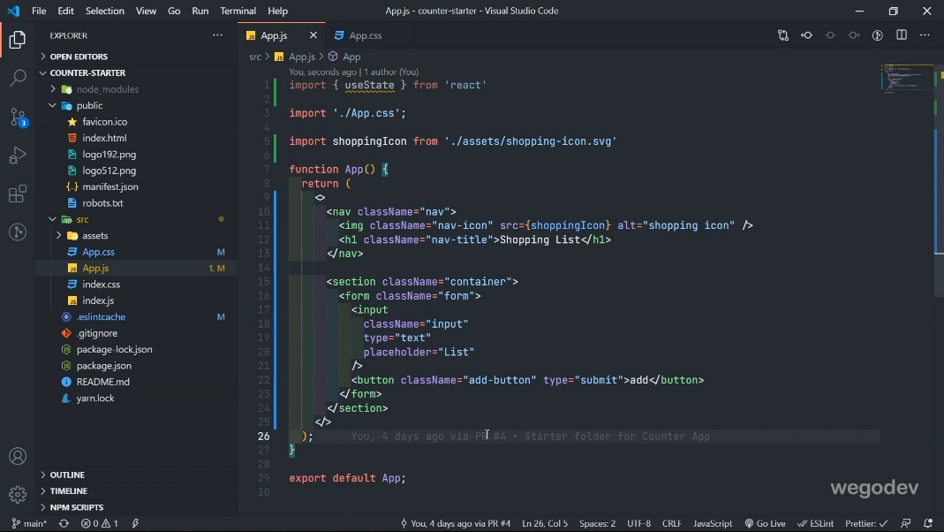

1. Event handlin on input element

* We add useState
  + const [value, setValue] = useState("");
* We add onChange and value in the input tag.
  + *onChange*={(*e*) => {setValue(*e*.target.value)}}
  + *value*={value}

1. Create todos state and Todos div (video 15)